**EXERCISE 4B. CROSSING A RIVER**

|  |  |
| --- | --- |
| *OBJECTIVE*  **After this exercise the participants will be able to:**   * Explain the roles of the field agent and group members in developing an agroenterprise. | |
| *EQUIPMENT NEEDED*   * Two pieces of rope or branches * Several sheets of A4 paper or a piece of chalk) | *EXPECTED OUTPUTS*   * The participants understand the role of the field agent, and their own role in learning the skills they will need. |
| *TIME*  1hour | *PREPARATION*   * Lay out the ropes or branches parallel to each other, 6–8 meters apart. These represent the banks of a river. * Scatter the pieces of paper on the ground between the “river banks”1-2 meters apart (or draw large circles on the ground with chalk). These represent stepping stones. |

This exercise illustrates the field agent’s role to empower and guide the community.

*SUGGESTED PROCEDURE*

1. Take aside three members of the group and instruct them for a three-act role play (see below).
2. Explain to the audience that the rope or sticks are the river banks and that two people are trying to cross the river. They want to find something better on the other side.
3. Invite the three actors – a “field agent” and two “farmers” – to act out the play in silence to the rest of the group.
4. **Act 1:** Starting on the near bank of the river, the field agent and one of the farmers try to cross the river using the stepping stones. The field agent tries to carry the farmer across the river on his or her back.
5. But the field agent gets tired.
6. So he or she leaves the farmer in the middle of the river and goes back to the near bank. The farmer who was being carried is abandoned, and the field agent leaves the scene, complaining about being tired.
7. **Act 2:** The field agent tries to cross the river with the second farmer. This time, he or she does not carry the farmer, but instead holds his or her hand and shows where the next stone is positioned.
8. The field agent and second farmer take time to cross the river but in the end they succeed in reaching the far bank. They celebrate when they reach the other side. The field agent then waves goodbye and leaves the scene. The second farmer returns to the near bank of the river.
9. **Act 3:** The second farmer takes a member of the audience and shows him or her how to cross the river. The person does not hold hands with the audience member, but leads him or her to the near bank and then shows where to step. The role play ends when the two people have finally crossed to the far bank.

* Lead a discussion about what the play represented. The river represents a challenge: **the work needed to find a new market opportunity**. The near bank is where the community is now. The far bank is where the community would like to be. To achieve their goal, community members must cross the river.
* In **Act 1**, the field agent brings everything to the farmer. In reality, this means supplying the community with free seeds, tools, fertilizer, credit, transport, and links with traders. But after some time, the field agent gets tired of continuing – and the project ends. When this happens, the farmer is left behind because he or she cannot get free seeds, tools, fertilizer, credit, or transport without the project, so does not know how to get to the other side of the river. That is, the farmer was being “carried”, and when support was withdrawn he or she was unable to continue along the same path.
* In **Act 2**, the field agent empowers the farmer by guiding him or her across the river, clearly showing the stepping stones to use to get to the other side. This time the farmer is slower to cross, but gets there by working with the service provider. At this point, the field agent leaves. However, the farmer has learned how to cross the river and can now return to where he or she was and, most importantly, help others to cross (**Act 3**).

*QUESTIONS TO STIMULATE DISCUSSION*

* Who are the three characters in the story? What does the river represent? What do the stepping stones represent? Who did what?
* Which approach (carrying or guiding) took longer? Which approach was more effective?
* What happens next? Can everyone now cross the river?
* How does this relate to ideas on enterprise skills, learning, and community empowerment?

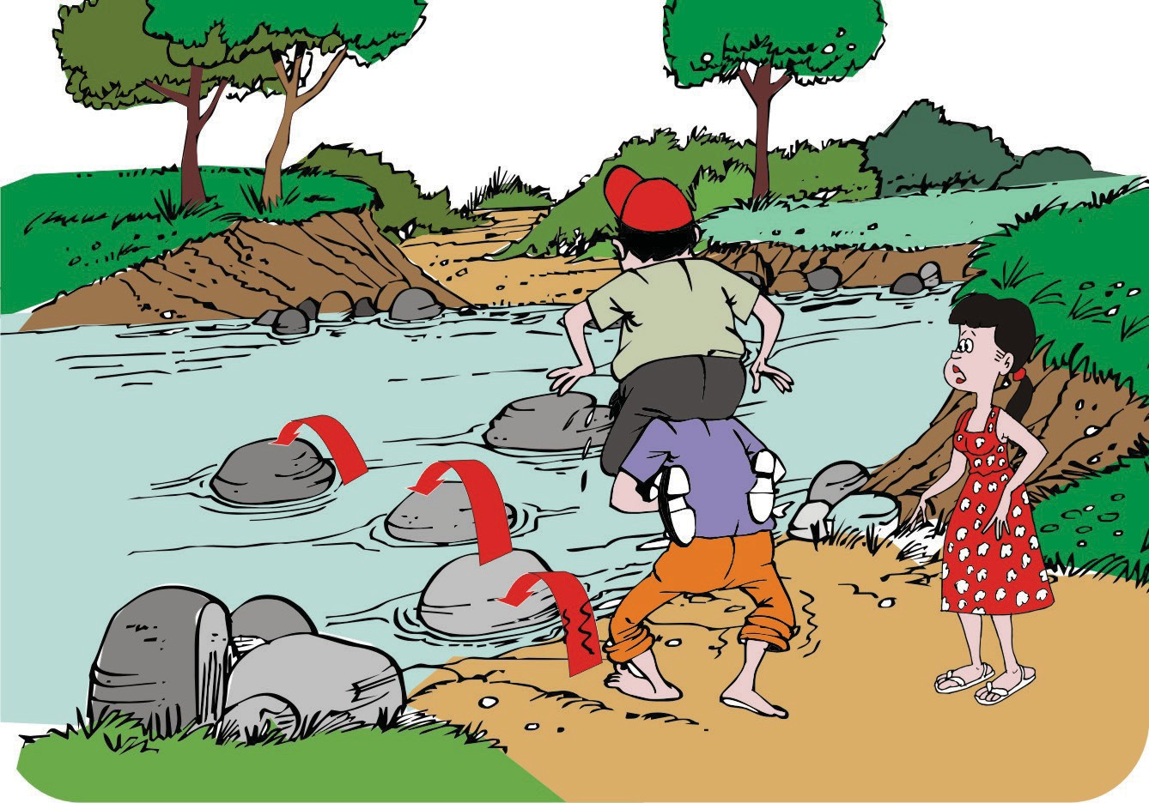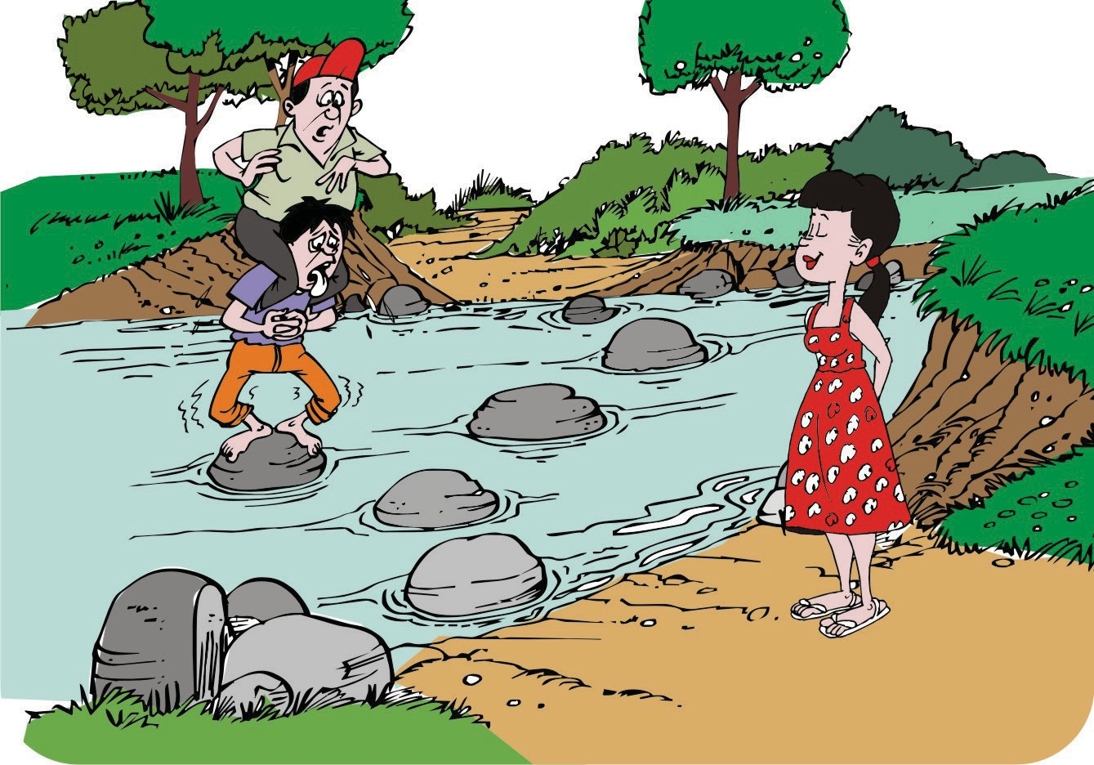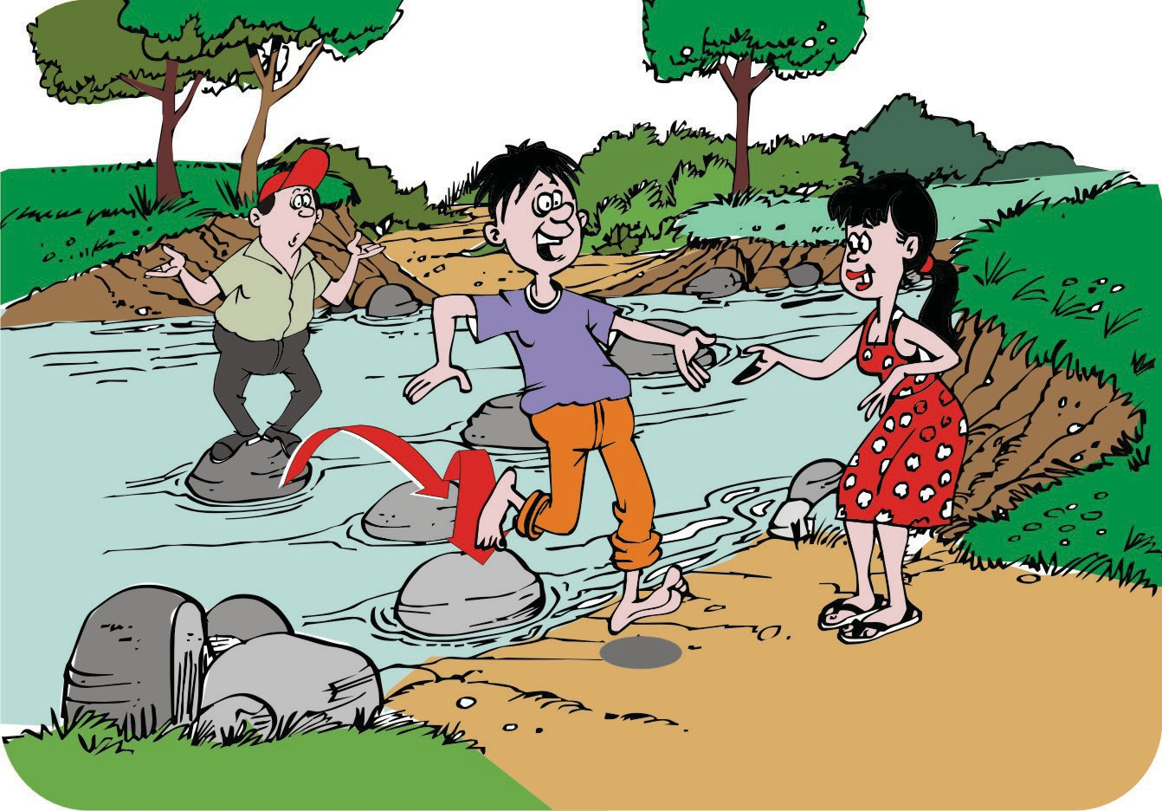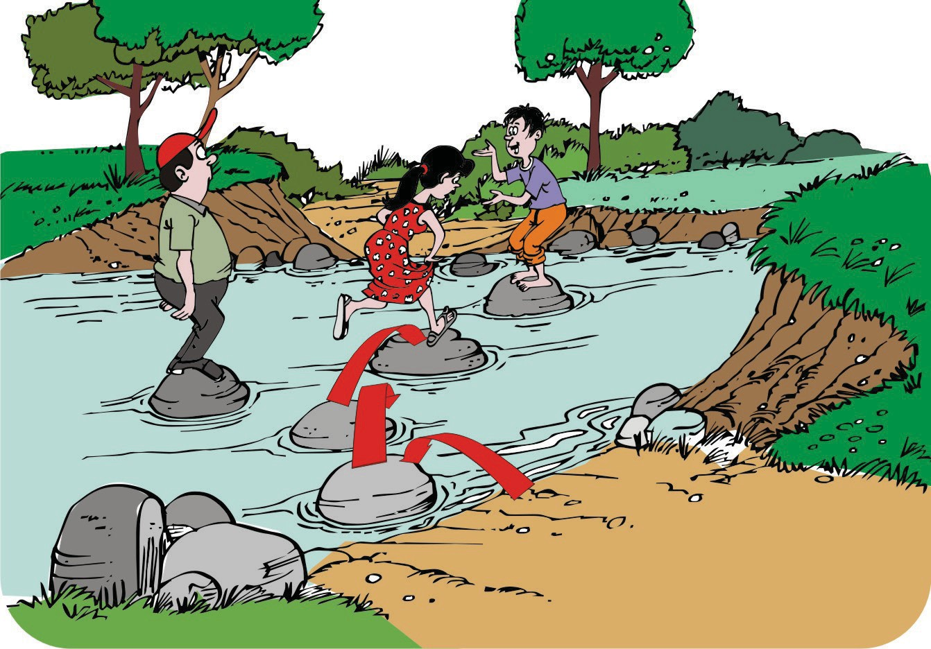

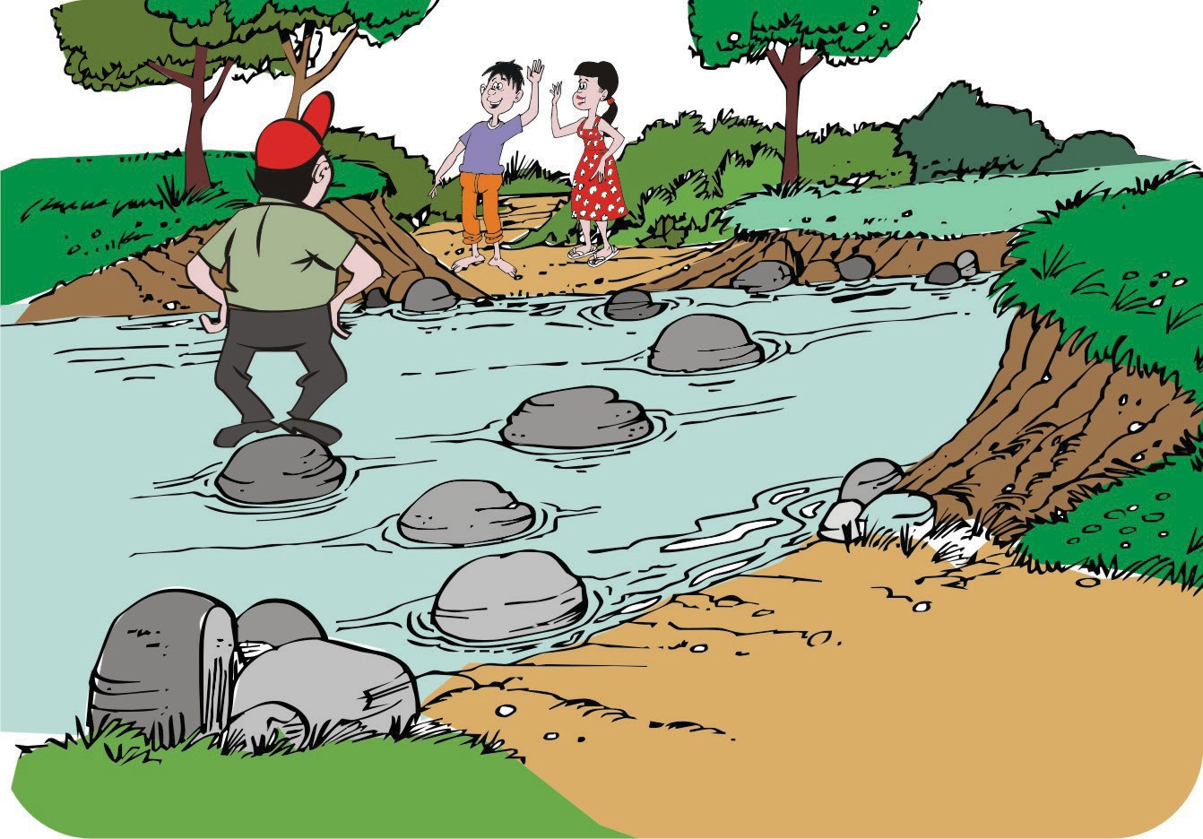INTRODUCTION TO SMART SKILLS FOR RURAL DEVELOPMENT 55